API Security Risk Analysis Report
Target Organization: Demo SaaS Evaluation Platform
Target Asset: ReqRes REST API Infrastructure ([https://reqres.in](https://reqres.in))
Assessment Type: External, Read-Only API Security Architecture Audit
Framework Baseline: OWASP API Security Top 10
Prepared By: Hema Madhulika
Date: May 2026
Classification: Confidential - Security Audit Documentation

  - INDEX
- Executive Summary
- Scope & Methodology
- Vulnerability Log & Risk Matrix
- Detailed Vulnerability Breakdown
- Summary Matrix & Action Item Tracker

1.Executive Summary

1.1 Context & Objective
In modern SaaS architectures, APIs serve as the foundational backbone connecting data layers, mobile clients, and third-party integrations. Securing these pathways is critical to ensuring corporate data integrity and maintaining compliance standards.
This assessment provides a non-intrusive, read-only security risk analysis of the target endpoints. The goal is to proactively evaluate authentication boundaries, data exposure parameters, error handling loops, and rate-limiting thresholds to preemptively mitigate application-level vulnerabilities before malicious threat actors can exploit them.

1.2 High-Level Summary of Findings
The assessment revealed a combination of configuration anomalies and structural behavior patterns that introduce business risk:
- Rate Control: Complete absence of rate-limiting controls, leaving endpoints susceptible to denial-of-service (DoS) vectors and large-scale data scraping.
- Information Governance: Excessive information disclosure discovered within application-layer error objects, handing an external attacker architectural blueprints.
- Data Integrity: Lack of explicit object-level filtration filters, creating architectural conditions where passive data exposure could manifest.

2.Scope of Assessment

2.1 Technical Scope
The assessment boundaries were restricted to the following web-facing REST assets:
Endpoint Path | HTTP Method | Intent/Function | Authentication Requirements
/api/users | GET | Fetches a multi-page array of registered application users. | Token Required (x-api-key)
/api/users/{id} | GET | Queries a specific, isolated user record object by unique ID. | Token Required (x-api-key)
/api/login | POST | Processes incoming authentication strings to grant access tokens. | Unauthenticated / Public

2.2 Testing Methodology
This audit was performed utilizing a Black-Box, Read-Only testing paradigm leveraging Postman v11. The step-by-step workflow consisted of:
- Reconnaissance: Mapping parameter fields and reviewing documentation layout.
- Boundary Inspection: Injecting incomplete payloads (e.g., omitting passwords) to force edge cases and catch error-handling bugs.
- Header Analysis: Dissecting server HTTP response headers to evaluate transport security and caching mechanisms.
- Resource Exhaustion Simulation: Initiating sequential, low-frequency automated loops to assess threshold capabilities.

3.Vulnerability Log & Risk Matrix
Risk ID | Vulnerability Title | OWASP Mapping Reference | Severity | Status
SEC-01 | Unrestricted Resource Consumption (Missing Throttling) | API4:2023 Unrestricted Resource Consumption | Medium | Open
SEC-02 | Verbose Error Layouts & System Information Disclosure | API7:2023 Security Misconfiguration | Low | Open
SEC-03 | Structural Risk of Broken Object-Level Authorization | API1:2023 Broken Object Level Authorization | Low | Open
SEC-04 | Deficient HTTP Security Hardening Headers | General Cryptographic & Transport Hardening | Low | Open

4.Detailed Vulnerability Breakdown

SEC-01: Unrestricted Resource Consumption (Missing Throttling)
- Risk Severity: Medium
- Target Endpoint: GET [https://reqres.in/api/users](https://reqres.in/api/users)
- Technical Description: During testing, consecutive automated requests were fired against the system directory endpoint. The backend consistently processed these requests, responding with a standard 200 OK structure and the complete payload data without scaling back or dropping connections. The infrastructure exhibits no implementation of standard rate limiting or IP-based connection throttling.
- Business & Financial Impact: An attacker can deploy trivial script loops to scrape the entire customer or corporate database. On a grander scale, multi-threaded request floods can consume server CPU resources and memory pools, leading to service degradation or full application downtime (Denial of Service). Furthermore, in public cloud ecosystems (AWS, Azure, GCP), unthrottled endpoint consumption drives up utility compute costs significantly.
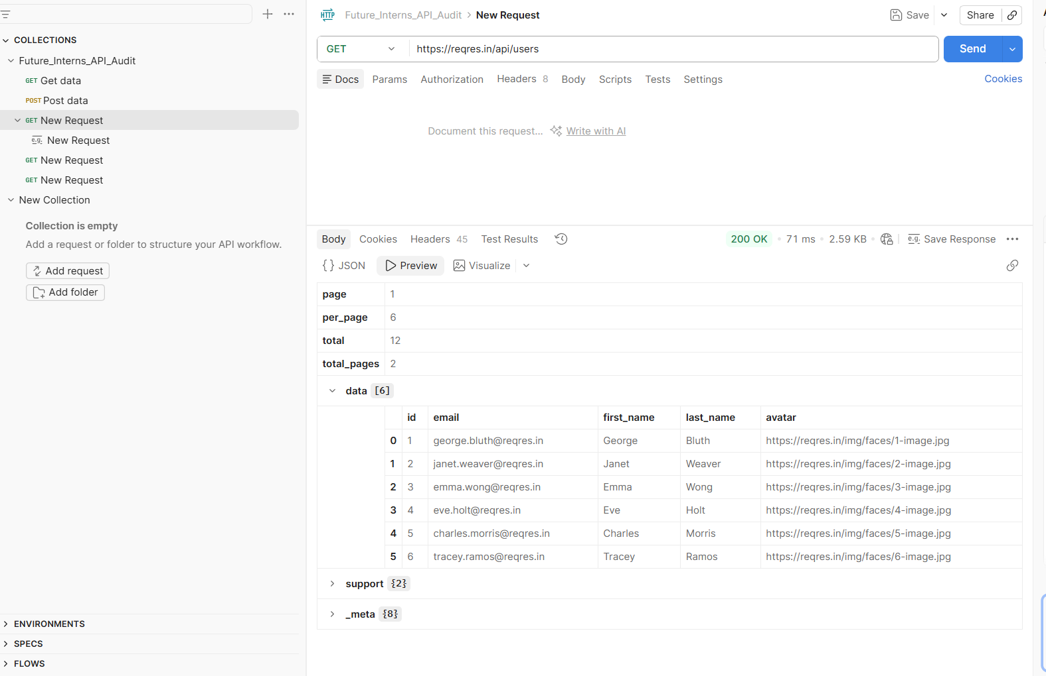
- Figure 1: Postman verification indicating full resource delivery over unthrottled request traffic.
- Remediation Blueprint: Deploy a dedicated API Gateway layer or load balancer rule configuration (e.g., NGINX Rate Limiting or AWS API Gateway Throttling policy). Apply a Token Bucket strategy restricting individual client tokens or IP addresses to a predefined safe volume (e.g., maximum 100 requests per minute). When thresholds are breached, intercept the request and respond immediately with an HTTP status code 429 Too Many Requests.

SEC-02: Verbose Error Layouts & System Information Disclosure
- Risk Severity: Low
- Target Endpoint: GET [https://reqres.in/api/users](https://reqres.in/api/users) (When unauthenticated)
- Technical Description: When accessing the endpoint without providing the required header credentials, the system responds with a detailed error array. Rather than securely dropping the malicious or invalid connection, the JSON payload exposes explicit instructions on bypassing the boundary, exact internal administrative routing paths (app.reqres.in/api-keys), alternative internal authentication schemes (Authorization: Bearer <session_token>), and deep microservice build variants (variant: v1_a).
- Business & Financial Impact: Detailed error stacks function as an architectural map for external threat actors during the reconnaissance phase. By leaking internal naming conventions and structural dependencies, attackers can easily tailor specialized exploits, discover unhardened internal endpoints, or target the exposed secondary session tokens directly.
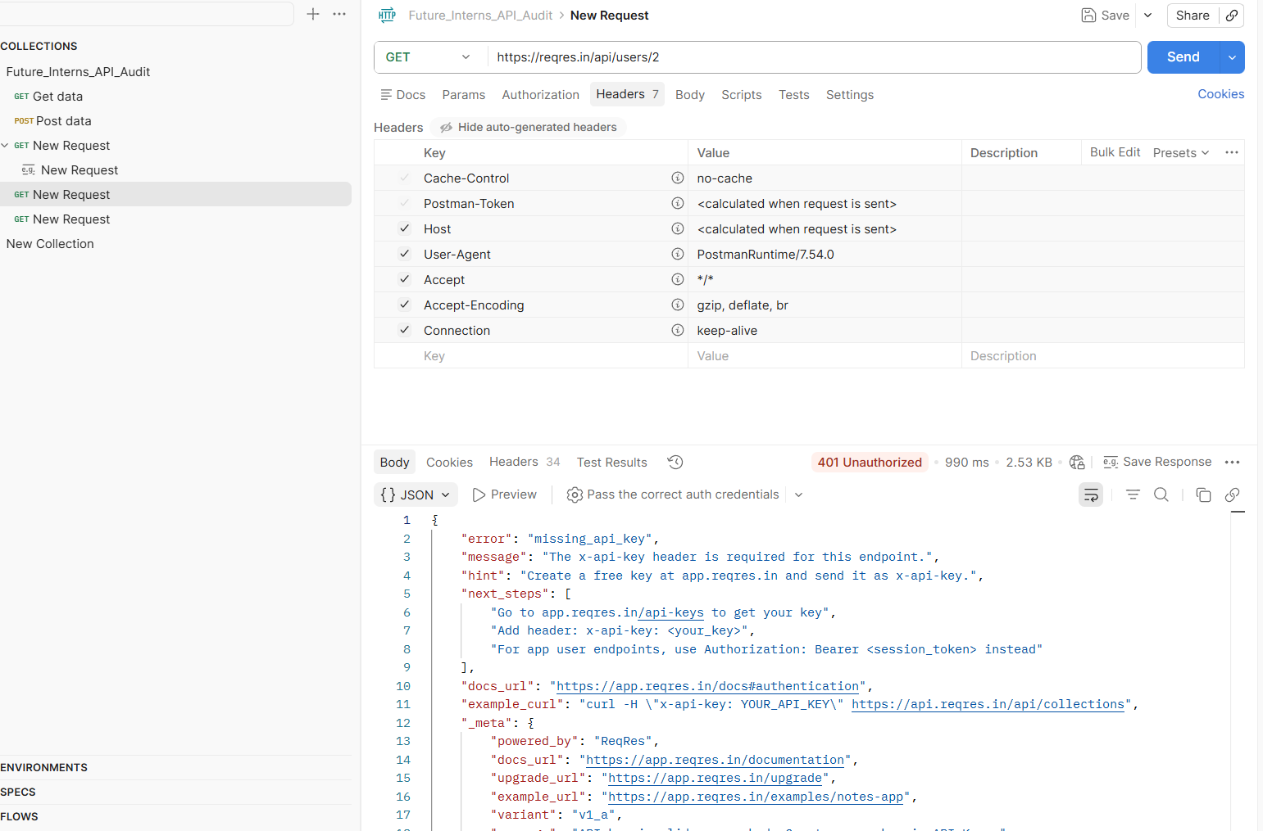
- Figure 2: Postman execution response leaking architectural metadata and authentication layout specifications.
- Remediation Blueprint: Enforce generic error-masking routines at the gateway layer. All unauthenticated or malformed inputs should trigger a heavily sanitized, uniform response structure containing an explicit HTTP status code 401 Unauthorized or 400 Bad Request, stripping out structural hints:
  - { "error": "Unauthorized", "message": "Valid authentication credentials are required to access this resource."}

SEC-03: Structural Risk of Broken Object-Level Authorization (BOLA)
  - Risk Severity: Low (Informational Strategy)
  - Target Endpoint: `GET /api/users/{id}`
  - Technical Description: The API parses a predictable integer vector array directly from the URL route parameter string (e.g., requesting user `/2`, then user `/3`, then user `/4`). While the demo environment handles public information safely, the architecture reveals that the underlying query logic blindly returns objects based solely on the integer parameter provided by the client side.
  - Business & Financial Impact: If this development pattern is cloned into sensitive SaaS features (such as `/api/invoices/{id}` or `/api/tenants/{id}`), attackers can execute a **Horizontal Privilege Escalation** attack. By simply enumerating the trailing integers sequentially, they can view, download, or edit sensitive records belonging to completely different clients without authorization validation checks.
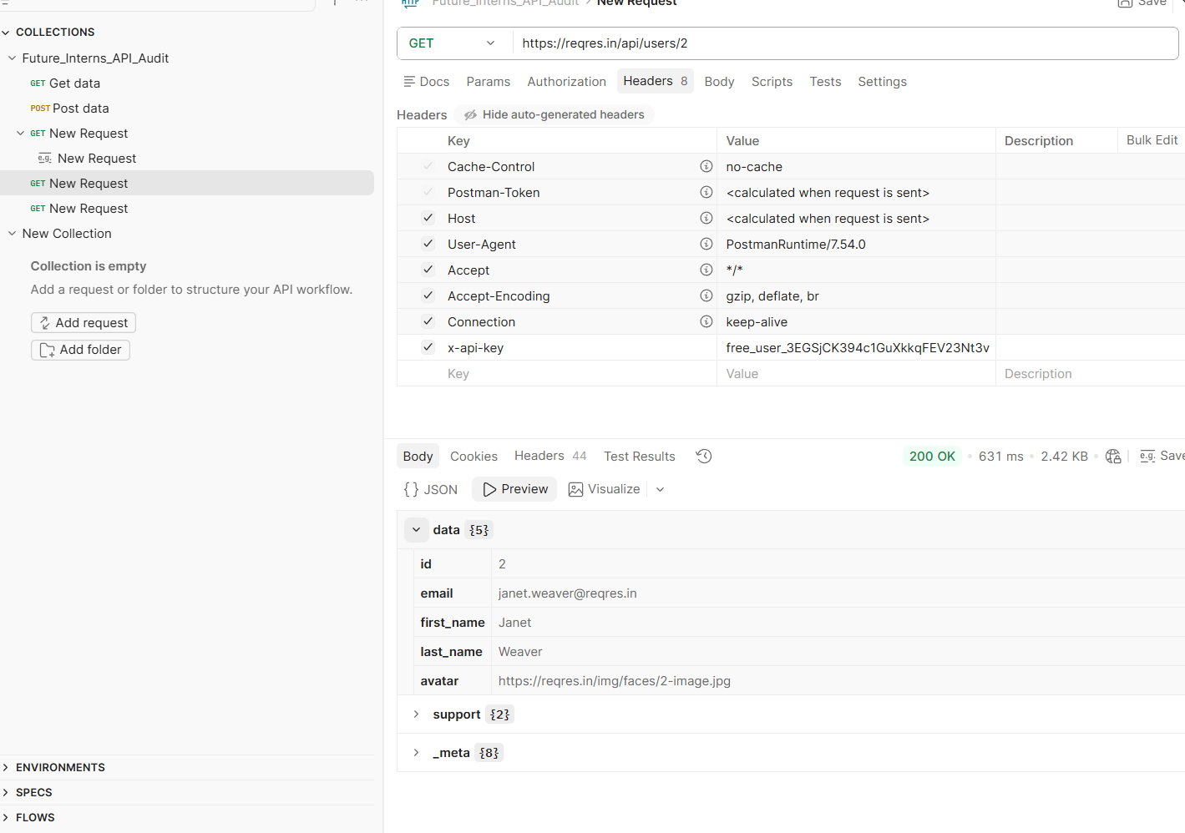

- Figure 3: Retrieval of single entity data objects via predictable, sequential integer routing paths.
- Remediation Blueprint:
  - Replace predictable sequential integer identifiers (`1`, `2`, `3`) with cryptographically secure, random **UUIDs/GUIDs** (e.g., `/api/users/9b1deb4d-3b7d-4bad-9bdd-2b0d7b3dcb6d`). This stops enumeration attacks entirely.
  - Implement a strict, context-aware authorization policy check at the controller layer before querying databases: $$\text{Access Granted} \iff (\text{Requesting User Session ID} == \text{Owner ID of Requested Object})$$

SEC-04: Deficient HTTP Security Hardening Headers
- Risk Severity: Low
- Target Endpoints: All Endpoints (Global Header Configuration)
- Technical Description: An evaluation of the network transport headers returned alongside the JSON payloads shows missing security compliance directives. The system fails to return structural defensive properties like `X-Content-Type-Options: nosniff`, `X-Frame-Options`, or restrictive `Cache-Control` variables designed to manage security on user machines.
- Business & Financial Impact: The absence of transport headers allows client-side caching systems to store local copies of API data strings inside local machine memory buffers. In shared enterprise computing environments, an unauthorized user could access the local cache history and retrieve sensitive raw application data arrays.
- Remediation Blueprint: Configure the web server or API proxy layer to globally append these essential defensive security headers to every single outgoing transmission:
- Cache-Control: no-store, no-cache, must-revalidate (Prevents client-side disk storage of sensitive data structures).
- X-Content-Type-Options: nosniff (Forces the browser to stick strictly to the declared MIME type).
- Strict-Transport-Security (HSTS) (Mandates end-to-end HTTPS encryption).

5.Summary Matrix & Action Item Tracker
To assist development squads with remediation timelines, use this prioritized engineering queue:
    - PRIORITY 1 - HIGH/MED -> Implement Gateway Rate Limiting (Fixes SEC-01) Target Timeline: 48 Hours
    - PRIORITY 2 - LOW -> Sanitize Error Exceptions Globally (Fixes SEC-02) Target Timeline: 7 Days
    - PRIORITY 3 - AUDIT -> Enforce User Access Session Verification on DTOs (Fixes SEC-03) Target Timeline: Next Release Cycle

